**Quantitation of human enteric viruses as alternative indicators of fecal pollution to evaluate wastewater treatment processes**

Audrey Garcia and Miguel Uyaguari-Diaz

Antimicrobial Resistance and the Environment Plus Laboratory (ARE+)

Department of Microbiology, University of Manitoba, Winnipeg, MB, Canada

**ABSTRACT**

We investigated the potential use and quantitation of human enteric viruses in wastewater samples as alternative indicators of contamination and evaluate the processing stages of the wastewater treatment plant. During the fall 2019 and winter 2020 seasons samples of raw sewage, activated sludge, effluents and biosolids (sludge cake) from the North End Sewage Treatment Plant (NESTP), the largest wastewater treatment plant in Winnipeg, Manitoba, Canada were collected. DNA and RNA enteric viruses and *uidA* gene (found in *Escherichia coli*) were targeted in the samples collected from the NESTP. Total nucleic acids from each wastewater treatment sample was extracted using a commercial spin-column kit. Enteric viruses were quantitated in the extracted samples via quantitative PCR using TaqMan assays. The average gene copies assessed in the raw sewage were not significantly different (INCLUDE p-value here) than the average gene copies assessed in the effluents for Adenovirus and CrAssphage (DNA viruses), Pepper Mild Mottle Virus (PMMV) (RNA virus), and *uidA* in terms of both volume and biomass. The significant reduction of these enteric viruses and *uidA* was observed consistently in activated sludge samples. The higher gene copy numbers of enteric viruses and *E. coli* observed in the effluents may be associated with the 12-hour hydraulic retention time in the facility. When compared to *uidA*, enteric viruses were found at least one to two orders of magnitude higher than the *E. coli* marker. This may indicate that enteric viruses can survive during the wastewater treatment process and therefore suggest that viral-like particles are being released into the aquatic environment.

**INTRODUCTION**

The human fecal waste present in raw sewage contain pathogens that can cause numerous diseases. This can have a huge negative impact to public and aquatic health and the economy (Stachler et al. 2017). Wastewater treatment plants (WWTPs) serve as a link between societies and the environment by reducing the organic matter present in wastewater. Water quality is currently assessed using traditional markers such as coliforms and *E. coli*, leaving other microbes such as viruses largely unexplored. The North End Sewage Treatment Plant (NESTP) in Winnipeg, Manitoba provides 70% of the city’s wastewater treatment (serving over 400,000 people) (City of Winnipeg, 2019b). The wastewater treatment at the NESTP involves raw sewage undergoing primary treatment, in which solids are removed. It then gets processed to the stage of activated sludge, in which a heterotrophic cocktail of bacteria and protozoa degrade organic matter present in solid waste. After this treatment cycle, activated sludge is removed. The treated water is disinfected and is discharged (known as effluents) into the river (City of Winnipeg, 2019a). Approximately 200 million liters of effluents are discharged per day (City of Winnipeg, 2019b). The main indicator of contamination used in wastewater treatment screening is *E. coli* (a fecal coliform bacterium). *E. coli* is present in the gut of humans and warm-blooded animals and widely used as a marker for the evaluation of fecal pollution including the wastewater treatment process.Nevertheless, the use of only fecal bacteria indicators excludes other possible pathogenic markers present, such as human enteric viruses. Targeting these viruses in effluents could be a potential method used to monitor wastewater treatment process. Within this context, in a study conducted by Dutilh et al. (2014), the DNA CrAssphage genome was targeted in a human fecal sample. With further bioinformatics testing, it was predicted that the CrAssphage genome is highly abundant and it was identified in 73% of human fecal metagenomes surveyed (Dutilh et al. 2014). In a study conducted by Zhang et al. (2006), the most abundant fecal virus they found in dry weight fecal matter was the plant RNA virus, PMMV. In the present study, samples of raw sewage (RS), activated sludge (AS), effluents (EF) and biosolids/sludge cake (SC) from the NESTP were collected (during fall 2019 and winter 2020) to investigate the potential of quantitating human enteric viruses in wastewater samples as complementary indicators of contamination to evaluate the processing stages of wastewater treatment. DNA enteric viruses include Adenovirus and CrAssphage; while that RNA enteric viruses include Pepper Mild Mottle Virus (PMMV), GI & GII Norovirus, Astrovirus, and Rotavirus. We also included a molecular marker for *E. coli*, *uidA* gene in the samples collected from the NESTP.

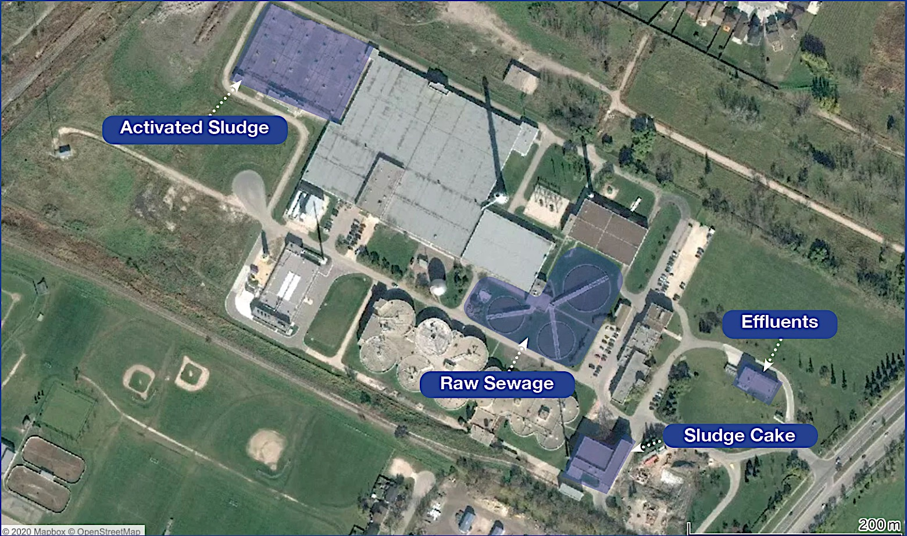

**Figure 1.** Satellite photo of the North End Sewage Treatment Plant.

**MATERIALS AND METHODS**

**Sample Collection**

RSASEFSCfrom the NESTP during fall 2019 and winter 2020. Samples were collected on October 22nd, 2019 (Event 1) and November 28th, 2019 (Event 2) in the fall season. In the winter season, samples were collected on December 18th, 2019 (Event 3) and February 6th, 2020 (Event 4). Sludge cake samples were collected on December 18th, 2019 and February 6th, 2020. These samples were kept at 4°C and processed within 24 h.

**Ultrafiltration of Wastewater Samples**

Each wastewater treatment sample (raw sewage, activated sludge, and effluents), including Millipore Milli-Q water as a negative control, was first filtered via a funnel and cheesecloth in order to remove any solid waste or debris. A volume of 140 mL of each wastewater sample was then concentrated down using an ultrafiltration method with Centricon Plus-70 filter units (Millipore Corporation, Billerica, MA). The steps of the ultrafiltration method were as follows. Using a sterile glass pipette, 70 mL of each wastewater sample was added into their correspondingly labeled sample filter cup pre-assembled with the filtrate collection cup. They were then sealed with a cap. The Centricon Plus-70 assemblies were placed into a swinging bucket rotor and then centrifuged at 3000 x g for 30 minutes at 20°C. Then, the filtrate was discarded and the remaining 70 mL of the samples was added into their correspondingly labeled sample filter cup pre-assembled with the filtrate collection cup. Samples were spun down using the same speed and temperature with the time duration set to 45 minutes. After centrifugation, the sample filter cup was separated from the filtrate collection cup. The concentration collection cup was then turned upside down and placed on top of the sample filter cup. The device was carefully inverted and placed into the centrifuge. Centricon Plus-70 filter units were centrifuged at 800 x g for 2 minutes at 20°C. After this step, the concentrated sample was collected from the concentration cup via a micropipette. The final volume was measured for each wastewater sample. If needed, TRIS buffer was added to the concentrate to make up a total volume of 250 μL. If the final volume of the concentrate was over 250 μL, TRIS was not added. Aliquots containing 250 μL were made and stored at -70°C until later use.

**Sludge Cake Preparation for Ultrafiltration**

To remove cells from the sludge cake sample, 1X phosphate-buffered solution (PBS) and 0.01% Tween pH 7.4 was used. Approximately 30 grams of sludge cake sample per sampling event (Events 3 and 4) were collected and divided into six Falcon tubes for each event (~5-6 grams per tube). Approximately 30 mL of PBS were added to each tube. The Falcon tubes filled with sludge cake samples were homogenized by vortexing them at constant agitation for 15 minutes at 2500 rpm. These tubes were then centrifuged at a speed of 4500 x g for 50 minutes. The supernatant from each tube was then recovered and transferred to a new sterile Falcon tube. For each sample event, 140 mL of supernatant was used for ultrafiltration as described previously.

**~~Ultrafiltration of Sludge Cake~~**

~~Event 3 and Event 4 sludge cake supernatants was concentrated down using the same ultrafiltration method as the wastewater samples by using Centricon Plus-70 filters. However, the first 70 mL of supernatant for each sample (Events 3 and 4) was centrifuged at a speed of 3000 x g for 1 hour. However, not all of the supernatant passed through the filters. Therefore, the filters containing sludge cake supernatants for each sample event were centrifuged again at a speed of 3000 x g for 45 minutes.~~

~~For the filtration of the remaining 70 mL of supernatant for each sludge cake sample event, two Centricon Plus-70 filters were used for each. Each Centricon Plus-70 filter had 35 mL of supernatant and they were each centrifuged at 3000 x g for 45 minutes. Not all of the filtrate passed through so it was centrifuged again at 3000 x g for 20 minutes.~~

**~~Preparation of Reagents for Nucleic Acid Extraction~~**

~~The QIAGEN Protease was prepared by adding 4.4 mL of Buffer AVE to the vial of lyophilized QIAGEN Protease. It was mixed carefully to avoid foaming. When not in use, the QIAGEN Protease was stored at -2-8°C. The use of Carrier RNA serves two purposes: it enhances binding of viral nucleic acids to the QIAamp MinElute membrane and the addition of large amounts of carrier RNA reduces the chance of viral RNA degradation in the rare event that RNase molecules escape denaturation by the chaotropic salts and detergent in Buffer AL. The Qiagen MinElute viral spin kit contained a tube of 310 μg of lyophilized carrier RNA in which 310 μl of Buffer AVE was added to the tube to obtain a solution of 1 μg/μl. The carrier RNA was dissolved thoroughly and divided into conveniently sized aliquots, and stored in the freezer at 20°C. Buffer AL and carrier RNA-buffer AVE mix were prepared following the manufacturer’s recommendations. Inverting the tube 10 times was done to gently mix the Buffer AL-carrier RNA mix. Buffer AW1 was prepared by adding 25 mL of ethanol (96-100%) to the bottle containing 19 mL of Buffer AW1 concentrate provided by the viral spin kit. The reconstituted Buffer AW1 was stored at room temperature (15-25°C). Buffer AW2 was prepared by adding 30 mL of ethanol (96-100%) to the bottle containing 13 mL of Buffer AW2 concentrate provided by the viral spin kit. The reconstituted Buffer AW2 was stored at room temperature (15-25°C).~~

**Nucleic Acid (DNA/RNA) Extraction and fluorometric assessment**

Once the final volume of concentrate was collected from each wastewater sample (as described above), we pretreated the sample with InhibitEX buffer (Qiagen Sciences, Maryland, MD) as indicated by the manufacturer. Then, QIAamp MinElute virus spin kit (Qiagen Sciences, Maryland, MD) was used to extract total nucleic acids from each wastewater sample. We followed the manufacturer’s instructions that included the use of Qiagen Protease and carrier RNA (Qiagen Sciences, Maryland, MD). Samples were eluted in 75 μL of Buffer AVE (Qiagen Sciences, Maryland, MD), quantified and stored at -80°C for downstream processes. We assessed nucleic acid concentration and purity using Qubit dsDNA high sensitivity and RNA assay kits in a Qubit 4 fluorometer (Invitrogen, Carlsbad, CA, USA).

~~. μL of . For each 250 μL of wastewater sample concentrate , we added 75 μL of . After adding the protease, 500 μL of Buffer AL (containing 11.2 μg/mL of Carrier RNA) and 500 μL of InhibitEX Buffer (at 70°C) were also added. The samples were then mixed by pulse-vortexing for 15 seconds. The samples were then incubated at 56°C for 15 minutes. The tubes containing the samples were then briefly centrifuged to remove drops from the inside of the lid. After brief centrifugation, 600 μL of ethanol (96-100%) was added to each sample. They were again mixed thoroughly by pulse-vortexing for 15 seconds. The lysates were then incubated with the ethanol for 5 minutes at room temperature (15-25°C). After incubation, the samples were again briefly centrifuged. Each lysate was carefully applied to its own MinElute column without wetting the rim. The columns were then centrifuged at 17 000 x g for 3 minutes until all the lysate passed through. After all the lysate passed through each column, the filtrate was discarded. A volume of 600 μL of Buffer AW1 was then added to each column. The columns were then centrifuged at 17 000 x g for 1 minute. After all the Buffer AW1 was drawn through, the filtrates were discarded and 750 μL of Buffer AW2 were added to each column. The filtrates were discarded and the columns were then centrifuged at 17 000 x g for 1 minute. After centrifugation and discarding the filtrate, 750 μL of ethanol (96-100%) was added to each column and was centrifuged at 17 000 x g for 1 minute. Each QIAamp MinElute column was placed into a clean 1.5 ml collection tube and centrifuged at 17 000 x g for 3 minutes to dry the membrane completely. Each column was then placed into a clean 2 mL microcentrifuge tube and the collection tubes with the filtrate were discarded. The lid of the column was carefully opened to apply 75 μL of Buffer AVE to the center of the membrane. The lid was then closed and the columns were incubated at room temperature for 1 minute. The columns were then centrifuged at 17 000 x g for 1 minute. After extraction, nucleic acid extracts were stored at -80°C for downstream processes.~~

**~~Measuring RNA and DNA Quantity~~**

~~A Qubit 4 Fluorometer (Invitrogen Thermo Fisher Scientific) was used to measure the quantity of RNA or DNA extracted. Two assay tubes for two standards were set up for the RNA assay and for the DNA assay, and one assay tube for each wastewater sample (raw sewage, activated sludge, effluents, and the negative control). The working solution for the RNA assay had to be prepared by diluting the Qubit reagent 1:200 in Qubit~~~~buffer, while the working solution for the DNA assay was already prepared for use. For each standard and sample, 200 μl of working solution was prepared. The assay tubes were prepared by following the manufacturer’s recommendations. The assay tubes were vortexed for 2-3 seconds and then incubated for 2 minutes at room temperature. The assay tubes were then inserted in the Qubit 4 Fluorometer to take the readings.~~

**DNA/RNA Quantitation via quantitative polymerase chain reaction (qPCR)**

Once viral RNA and DNA were assessed from the samples, a QuantStudio 5 PCR system (Applied Biosystems, Waltham, MA, USA) was used to quantitate enteric viruses in the wastewater treatment samples. Gene copy numbers (GCNs) were expressed in terms of volume (per milliliter or gram of sample) and biomass (ng of DNA or RNA). ~~These samples were then placed into an -80°C freezer in order to ensure the viral DNA/RNA was stable for nucleic acid extraction.~~ GCNs per ml of sample were calculated as previously described by (. When calculating for gene copies per ml sample, the final volume recovered after filtering 140 mL of wastewater sample was used in the formula. For the sludge cake samples, the mass of sludge cake collected in grams was used in the formula. As some of the RNA samples had yields below detection limit, but generated amplification. Therefore, GCNs per ng of RNA were estimated to be ≤0.025 ng/μl (limit of detection of Qubit RNA HS Assay Kit).

~~The following equation was used to calculate the~~ **~~number of gene copies~~**

~~The following equation was used to calculate the~~ **~~gene copies per ml~~** ~~of sample (Ritalahti et al. 2006):~~

**qPCR primers, probes and gBlocks Gene Fragments**

Table 1 summarizes the primers and probes from the literature used in this study. Forward and reverse primers described in Table 1 were used in Primer-BLAST tool to extract gene target regions. Extracted regions were then uploaded to Geneious software to verify oligonucleotide sequences associated to the flanking regions and probe as well. ~~to design forward and reverse primers to amplify selected genomic regions of Adenovirus, CrAssphage, Pepper Mild Mottle Virus, Sapovirus (Sav1, Sav124, and Sav5), Rotavirus, Astrovirus, and Norovirus (GI and GII), and~~ *~~uidA~~*~~.~~ These generated sequences were sent to Integrated DNA Technologies (IDT, Inc., Coralville, Iowa) to generate the desired gBlocks constructs. IDT manufactured all of the reverse and forward primers used for qPCR, as well as some of the probes. However, probes Sav124TP, Sav5TP, NSP3-P, AdV-P, PMMV-P, and CrAss-P were manufactured by Life Technologies.

**Table 1.** Primers and Probes used in the present study

|  |  |  |  |
| --- | --- | --- | --- |
| **Target** | **Primer/Probe** | **Sequence (5’-3’)** | **Genomic Target** |
| Sapovirus | Sav1F | TTG GCC CTC GCC ACC TAC | Junction of polymerase and capsid |
| Sav5F | TTT GAA CAA GCT GTG GCA TGC TAC |
| Sav124F | GAY CAS GCT CTC GCY ACC TAC |
| Sav124R | CCC TCC ATY TCA AAC ACT A |
| Sav124TPa (Probe) | FAM-CCR CCT ATR AAC CA |
| Sav5TPa (Probe) | FAM-TGC CAC CAA TGT ACC A |
| Rotavirus Type A | NSP3-F | ACC ATC TWC ACR TRA CCC TCT ATG AG | Non structure Protein 3 |
| NSP3-R | GGT CAC ATA ACG CCC CTA TAG C |
| NSP3-Pa (Probe) | VIC-AGT TAA AAG CTA ACA CTG TCA AA |
| Adenovirus 40/41 | AdV-F | GCC TGG GGA ACA AGT TCA G | Hexon |
| AdV-R | ACG GCC AGC GTA AAG CG |
| AdV-Pa (Probe) | NED-ACC CAC GAT GTA ACC AC |
| Astrovirus | Ast-F | AAG CAG CTT CGT GAR TCT GG | Junction of polymerase and capsid |
| Ast-R | GCC ATC RCA CTT CTT TGG TCC |
| Ast-Pb (Probe) | Cy5-CAC AGA AGA GCA ACT CCA TCG CAT TTG |
| GI | Cog1F-flap | AATAAATCATAACGYTGGATGCGNTTYCATGA | Norovirus GI |
| Cog1R-flap | AATAAATCATAACTTAGACGCCATCATCATTYAC |
| Ring1a.2 (Probe) | 6-FAM- AGATYGCGR/ZEN/ TCYCCTGTCCA -IBFQ |
| GII | Cog2F-flap | AATAAATCATAACARGARBCNATGTTYAGRTGGAT GAG | Norovirus GII |
| Cog2R-flap | AATAAATCATAATCGACGCCATCTTCATTCACA |
| Ring 2.2 (Probe) | JOE - TGGGAGGGY/ZEN/ GATCGCAATCT - IBFQ |
| CrAssphage | CrAss-F | CAG AAG TAC AAA CTC CTA AAA AAC GTA GAG | Genomic base pair region: 14731 bp-14856 bp |
| CrAss-R | GAT GAC CAA TAA ACA AGC CAT TAG C |
| CrAss-P (Probe) | FAM-AAT AAC GAT TTA CGT GAT GTA AC |
| Pepper Mild Mottle Virus | PMMV-FP1-rev | GAG TGG TTT GAC CTT AAC GTT TGA | 1878 bp-1901 bpc  and  1945 bp-1926 bpc |
| PMMV-RP1 | TTG TCG GTT GCA ATG CAA GT |
| PMMV-P (Probe) | FAM-CCT ACC GAA GCA AAT G |
| *Escherichia coli* | uidA_784F | GTG TGA TAT CTA CCC GCT TCG C | *uidA* |
| uidA_866R | AGA ACG GTT TGT GGT TAA TCA GGA |
| EC807d probe | FAM-TCGGCATCCGGTCAGTGGCAGT-BHQ1 |
| aQuencher: MGB-NFQ.  bQuencher: Tao-IBDRQ.  cCorresponding nucleotide position of GenBank accession number M81413 (PMMoV strain S)  dQuencher: Iowa Black fluorescent | | | |

**Quantitative PCR assays**

Taqman Environmental Master Mix 2.0 (Life Technologies) was used for the DNA enteric viruses and *uidA*, while 4x Taqman Fast Virus 1-Step Master Mix (Life Technologies) was used for RNA enteric viruses. Each 10 μl qPCR reaction contained 500 nM of each forward primer and reverse primer and 250 nM μl of its designated probe when targeting for both DNA and RNA virus. Five μl of Environmental Master Mix was in each qPCR reaction for targeting DNA viruses, while 2.5 μl of 4x Fast Virus Master Mix was in each qPCR reaction for targeting RNA viruses. The *uidA* qPCR reaction consisted of 5 μl of Environmental Master Mix, 0.4 μM of each primer, 0.1 μM of probe. All qPCR reactions used 2 μl of template.

Each qPCR assay for DNA and RNA viruses were performed in triplicates on the ABI QuantStudio 5 PCR system (Applied Biotechnologies). The DNA enteric viruses (Adenovirus and CrAssphage) and *uidA* ran under the following conditions: 50.0°C for 2 minutes and 95.0°C for 10 minutes followed by 40 cycles of 95.0°C for 15 seconds and 60.0°C for 1 minute. The RNA enteric viruses (Sapovirus, Rotavirus, Astrovirus, GI and GII Norovirus, PMMV) ran under the following conditions: 50.0°C for 5 minutes and 95.0°C for 20 seconds followed by 40 cycles of 95.0°C for 3 seconds and 60.0°C for 30 seconds.

**Table 2.** Water quality parameters of wastewater treatment samples from NESTP

|  |  |  |  |  |  |  |  |  |
| --- | --- | --- | --- | --- | --- | --- | --- | --- |
|  | | **Raw Sewage** | | **Activated Sludge** | **Effluents**  (Final Grab Sample) | | | **Sludge Cake** |
| **Event #** | **Date** | **Avg. Flow Rate (MLD)** | **Avg. Daily Temp. (°C)** | **Avg. Flow Rate (mg/L)**  **(Suspended solids)** | **Temp. (°C)** | **Fecal Coliform (MPN/100mL)** | ***E. coli* (MPN/100mL)** | **Avg. Depth (cm)** |
| **Event 1** | 10/21/2019 | 352.90 | 13.6 | 9,917 | 14.1 | (2,500) | (1,730) | 25 |
| **10/22/2019** | 341.29 | 13.0 | 10,567 | 13.4 | 100 | 60 | 30 |
| 10/23/2019 | 288.97 | 13.4 | 11,067 | 14.0 | 6,130 | nra | 21 |
| **Event 2** | 11/27/2019 | 172.43 | 13.0 | 11,833 | 13.8 | 20 | 20 | 30 |
| **11/28/2019** | 158.43 | 13.1 | 9,883 | 14.1 | 20 | 60 | 19 |
| 11/29/2019 | 157.56 | 13.2 | 9,567 | 14.4 | 40 | 30 | 16 |
| **Event 3** | 12/17/2019 | 134.68 | 13.4 | 8,967 | 14.0 | 10 | 20 | 18 |
| **12/18/2019** | 141.29 | 13.3 | 9,017 | 14.1 | 40 | 90 | 21 |
| 12/19/2019 | 128.42 | 13.3 | 9,367 | 14.2 | 20 | 50 | 19 |
| **Event 4** | 02/05/2020 | 139.51 | 12.3 | 8,683 | 13.1 | 80 | 50 | 16 |
| **02/06/2020** | 135.85 | 12.3 | 9,167 | 12.7 | 640 | 1,080 | 15 |
| 02/07/2020 | 129.90 | 12.7 | 8,883 | 13.0 | 1,620 | 1,210 | 15 |

anot recorded or no result

**Table 3.** Weather and climate dataa

|  |  |  |  |
| --- | --- | --- | --- |
| **Event #** | **Date** | **Mean Temp (°C)** | **Total Precipitation (mm)** |
| **Event 1** | 10/21/2019 | 6.0 | 4.6 |
| **10/22/2019** | 2.7 | 0.8 |
| 10/23/2019 | 2.0 | 0.0 |
| **Event 2** | 11/27/2019 | -5.0 | 0.0 |
| **11/28/2019** | -6.6 | 0.0 |
| 11/29/2019 | -4.2 | 0.1 |
| **Event 3** | 12/17/2019 | -18.3 | 0.0 |
| **12/18/2019** | -17.0 | 0.0 |
| 12/19/2019 | -11.0 | 0.0 |
| **Event 4** | 02/05/2020 | -10.2 | 0.0 |
| **02/06/2020** | -17.1 | 0.8 |
| 02/07/2020 | -21.2 | 0.0 |

aWeather and climate data for the Forks, Winnipeg, MB (closest location near the NESTP)

(Government of Canada, 2019).

**RESULTS**

The gene copy values for the DNA and RNA viruses and *uidA* were transformed into log10 form. These values ran a Generalized Linear Model Tukey-Kramer analysis with 95% level of confidence (p level = 0.05). The means of each wastewater sample stage for each enteric virus targeted were analyzed. The gene copy numbers were expressed in terms of biomass and volume (except for sludge cake; it was expressed in grams). The presence of DNA and RNA viral gene copies and *uidA* in the Milli-Q water (negative control) samples across all Events 1-4 were negative. The red-dotted lines in Figures 2, 3, 4, 5, and 6 indicate the mean of the number of gene copies of each wastewater treatment sample across all events.

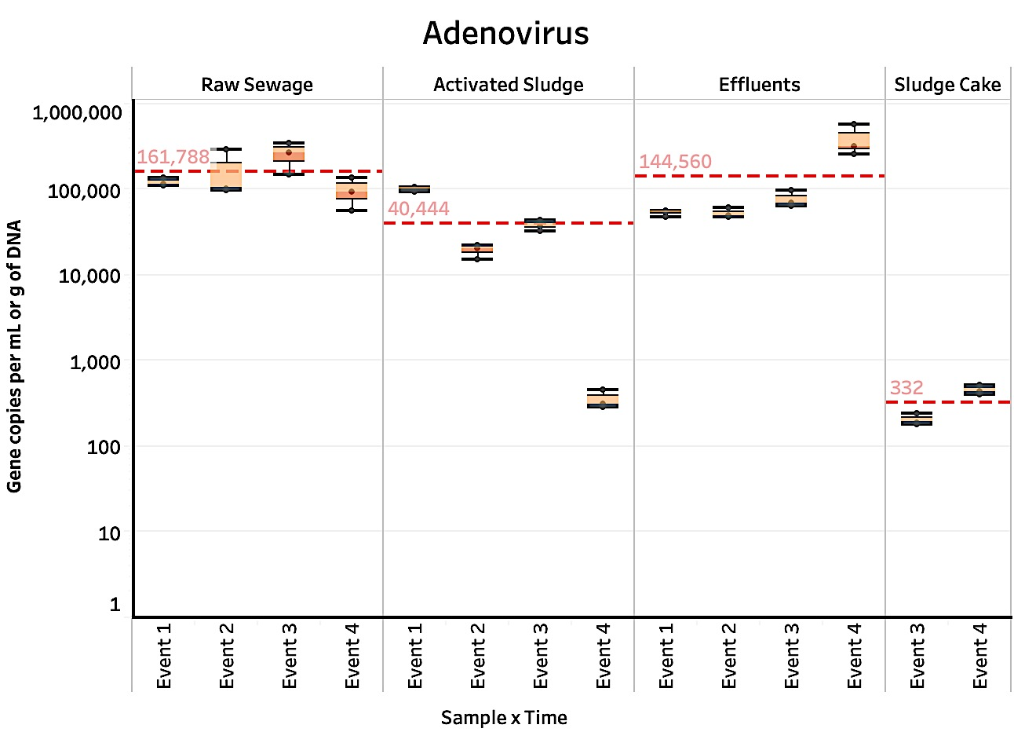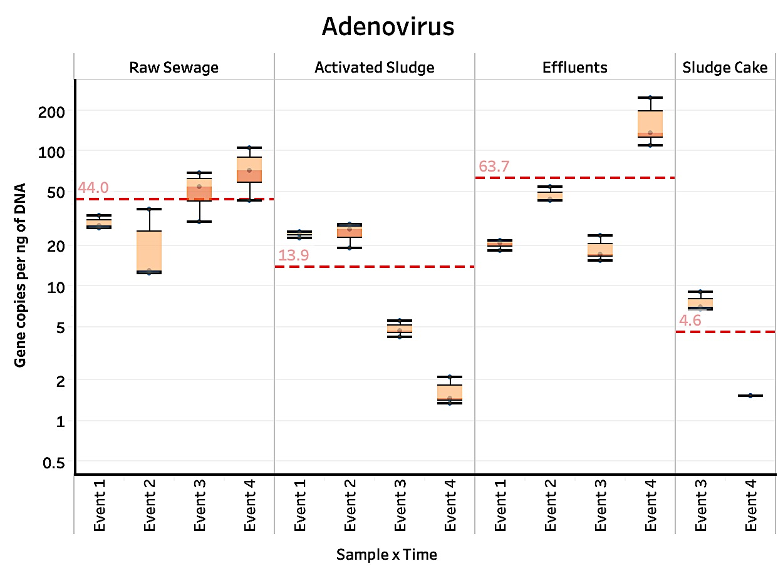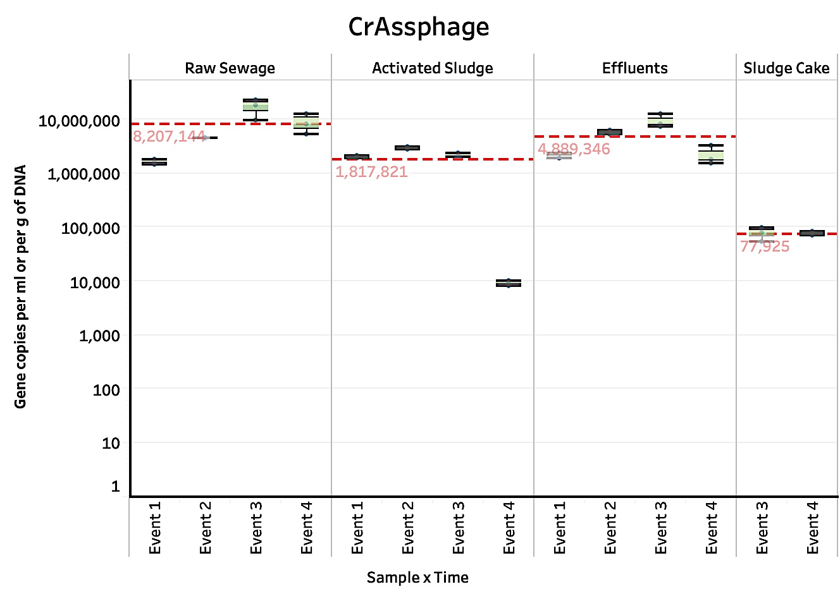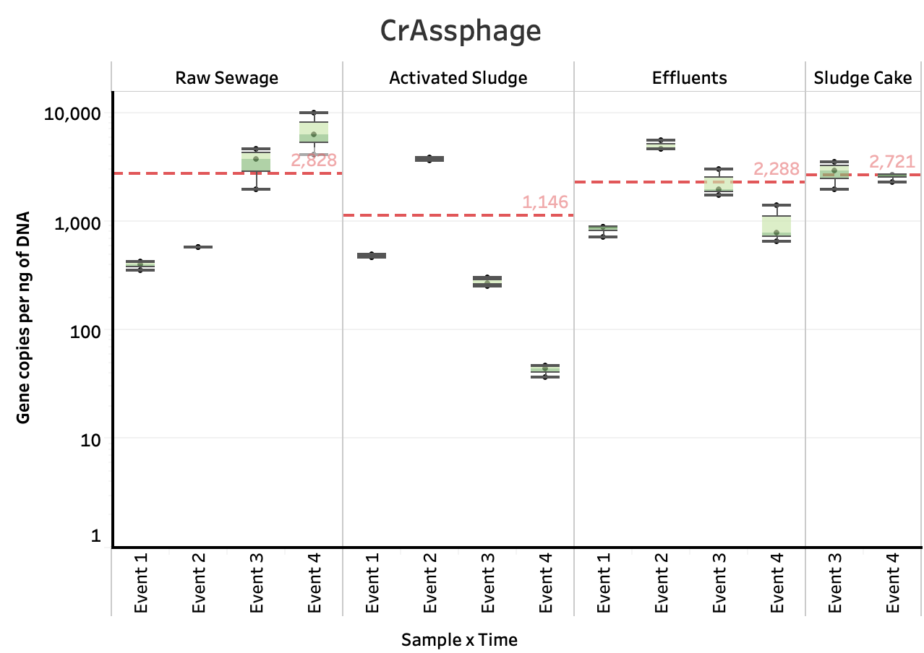

**Figure 2**. Box plot graphs of the number of genes copies of DNA enteric viruses across each wastewater stage throughout Events 1-4. The units for the sludge cake in Figures 2A and 2C are gene copies per gram of DNA.

**2B.**

**2A.**

**2C.**

**2D.**

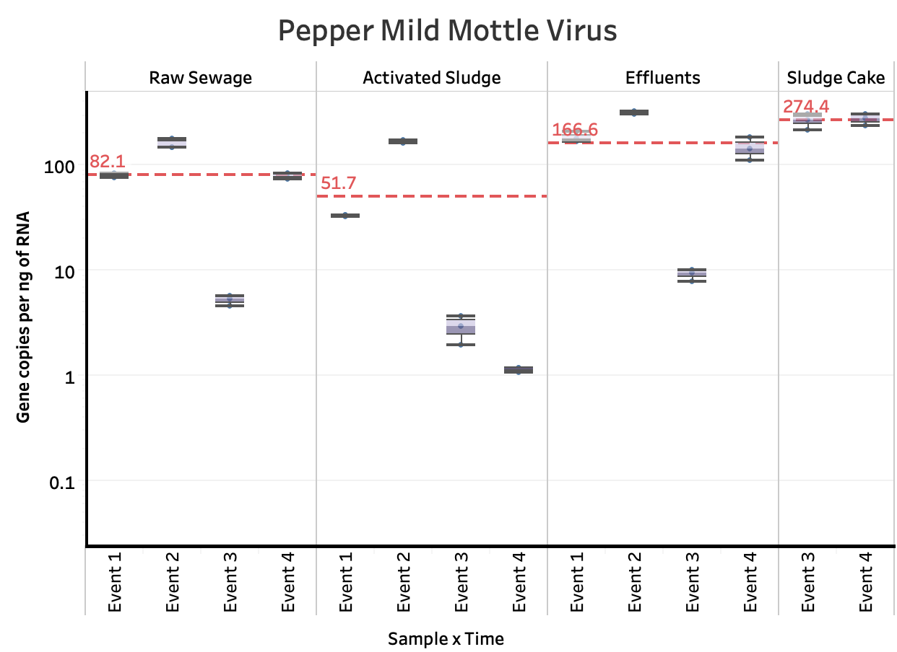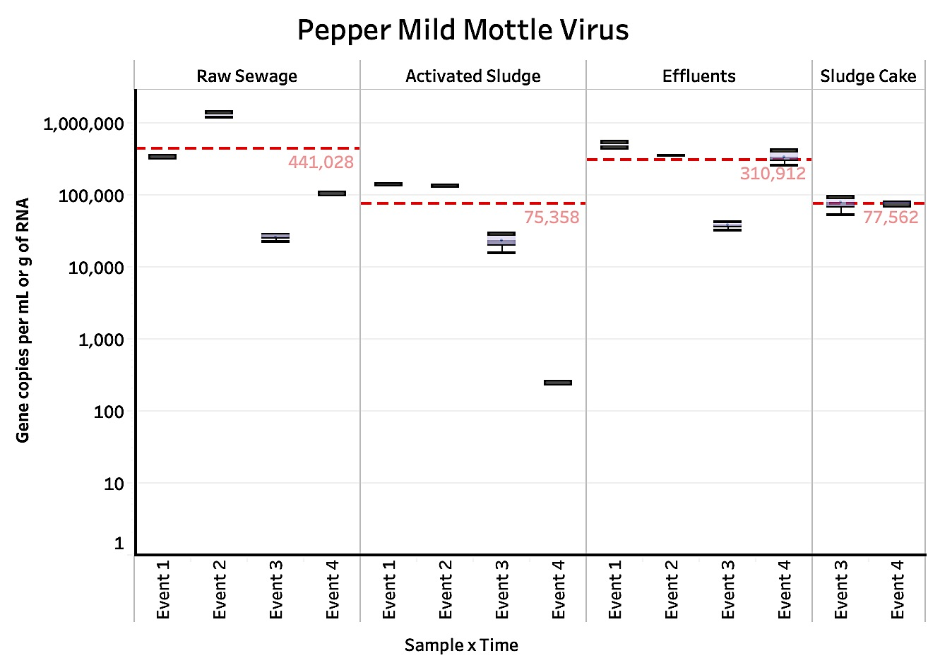

**3B.**

**3A.**

**Figure 3.** Box plot graphs of the number of genes copies of PMMV across each wastewater stage throughout Events 1-4. The units for the sludge cake in Figures 3A are gene copies per gram of RNA.

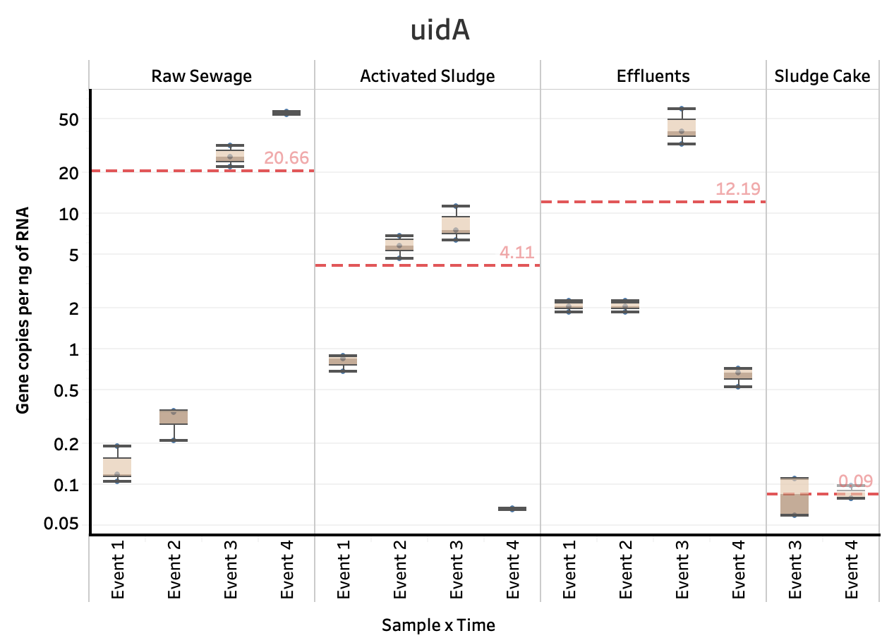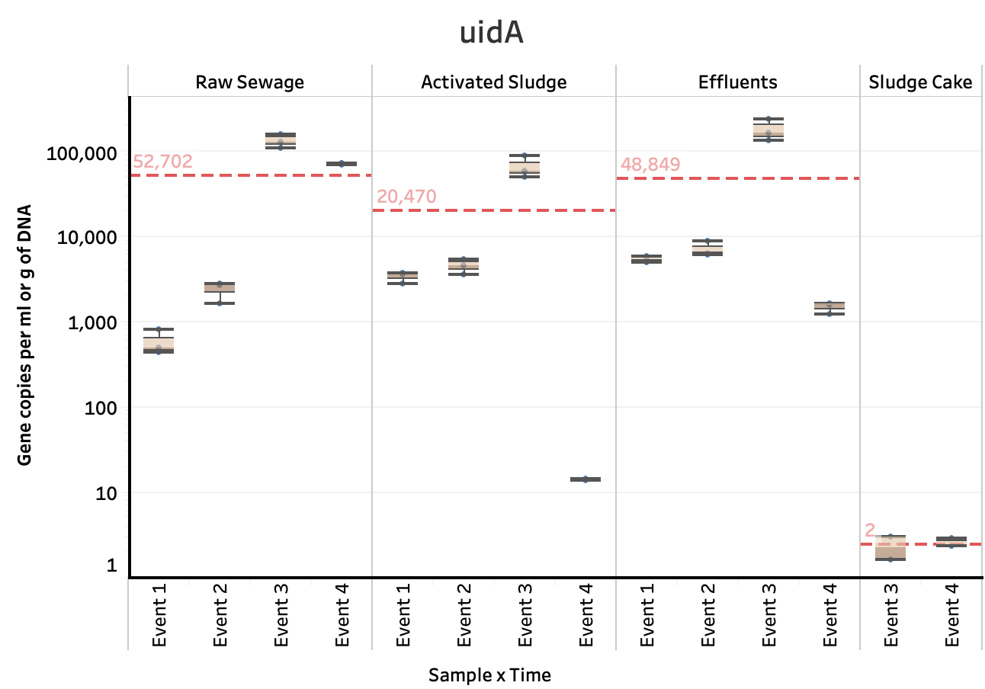

**4A.**

**Figure 4.** Box plot graphs of the number of genes copies of *uidA*. The units for the sludge cake in Figure 4A are gene copies per gram of DNA.

**4B.**

The average gene copies assessed in the raw sewage were not significantly different than the average gene copies assessed in the effluents for the DNA enteric viruses

(Adenovirus and CrAssphage), PMMV, and *uidA* (*E. coli*) in terms of both volume and biomass. However, the average gene copies assessed in the activated sludge was significantly lower compared to raw sewage and effluents. There was a consistent significant reduction of DNA enteric viruses; PMMV; and *uidA* gene copiesobserved in activated sludge samples and a relatively higher number of gene copies observed in the effluents across all Events 1-4 when compared to activated sludge samples.

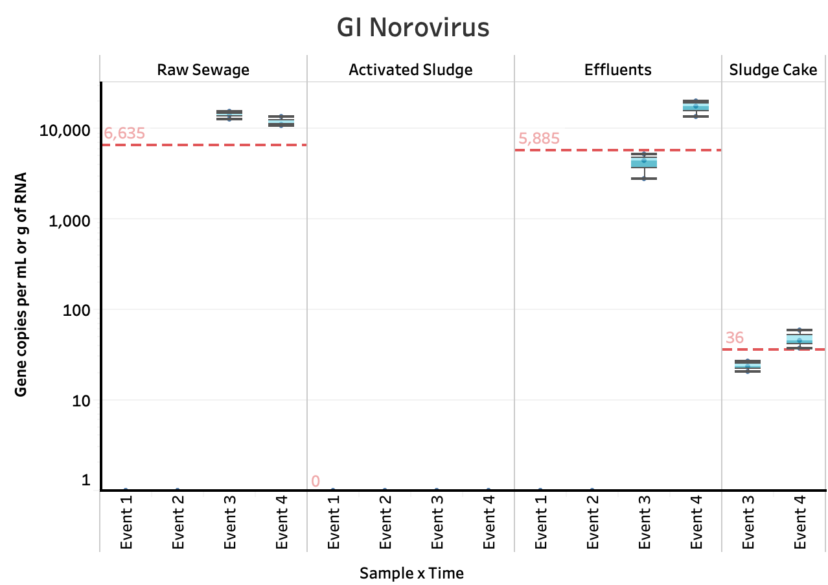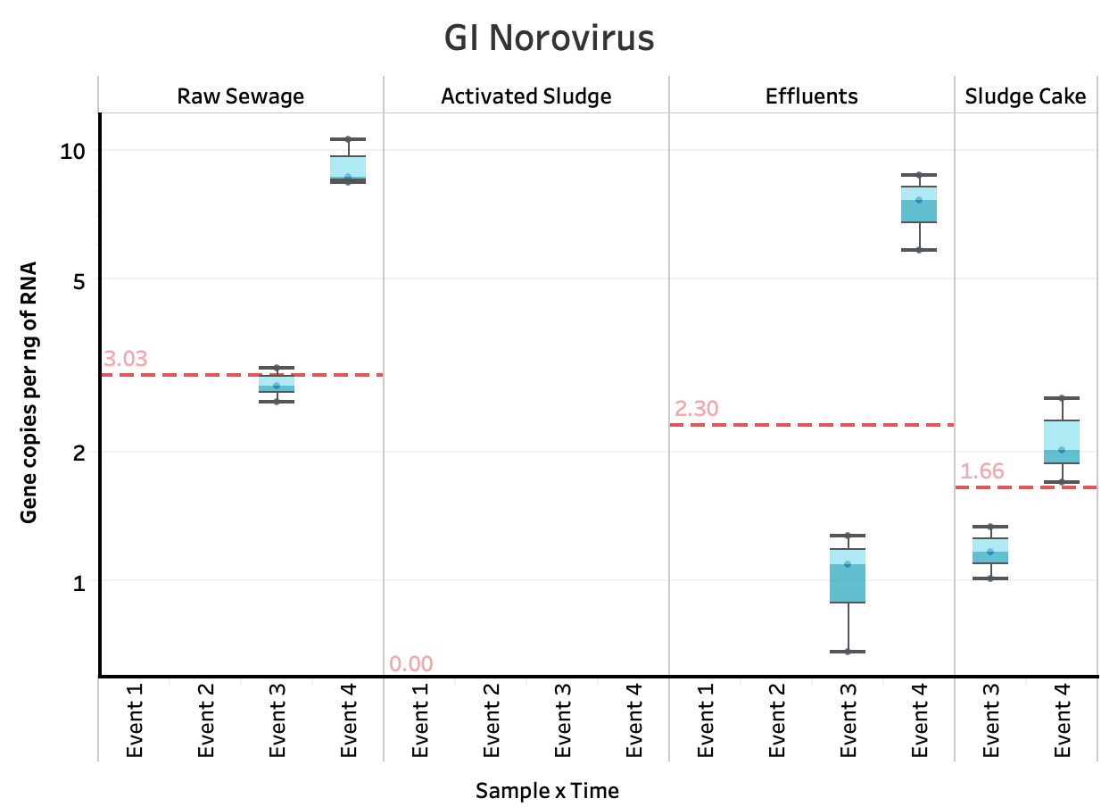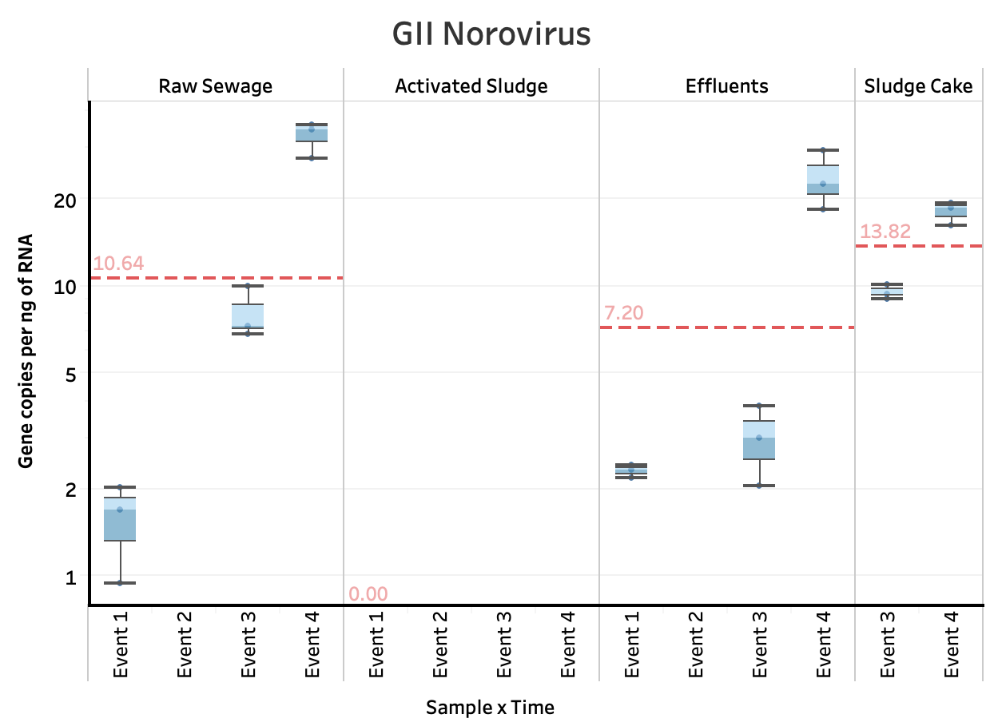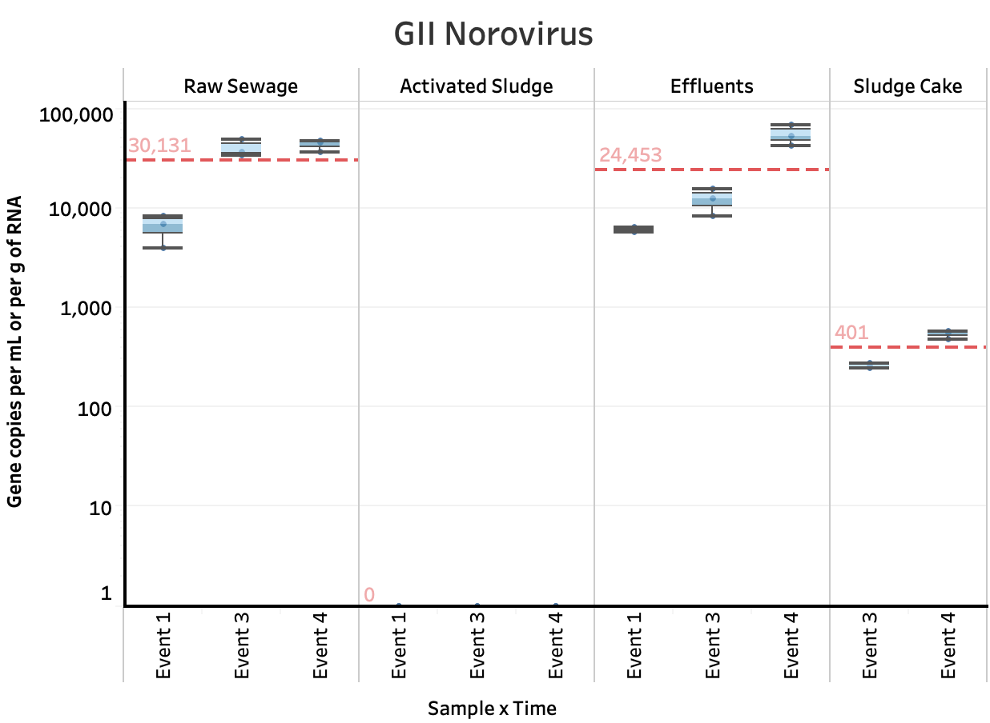

**5A.**

**5B.**

**5C.**

**5D.**

**Figure 5.** Box plot graphs of the number of genes copies of GI Norovirus and GII Norovirus across each wastewater stage. The units for the sludge cake in Figures 5A and 5C are gene copies per gram of RNA.

Across all Events 1-4, the detection of gene copies at the activated sludge wastewater stage for GI Norovirus (in terms of both volume and biomass) and GII Norovirus (in terms of biomass) was below the detection limit. The detection of gene copies for GI Norovirus in the raw sewage and effluents samples for Events 1 and 2 (fall season) were also below the detection limit. The gene copies of GI Norovirus were only detected in Events 3 and 4 (winter season) for raw sewage, effluents, and sludge cake. There was not a significant difference between the mean gene copies of GI Norovirus in the raw sewage and effluent samples in terms of both volume and biomass. Furthermore, there was not a significant difference in the average gene copies of GI Norovirus in the sludge cake and effluent samples in terms of biomass. In regards to GII Norovirus in terms of volume, no gene copies were detected in the activated sludge collected on Event 2. In addition, the detection of GII Norovirus gene copies was below the detection limit for the activated sludge in terms of volume for Events 1, 3, and 4. There was not a significant difference between the mean gene copies of GII Norovirus in the raw sewage and effluent samples in terms of both volume and biomass for Events 1, 3, and 4. Furthermore, there was not a significant difference between the mean gene copies of GII Norovirus in the effluents and raw sewage samples, as well as between the raw sewage and sludge cake samples in terms of biomass for Events 1, 3, and 4.

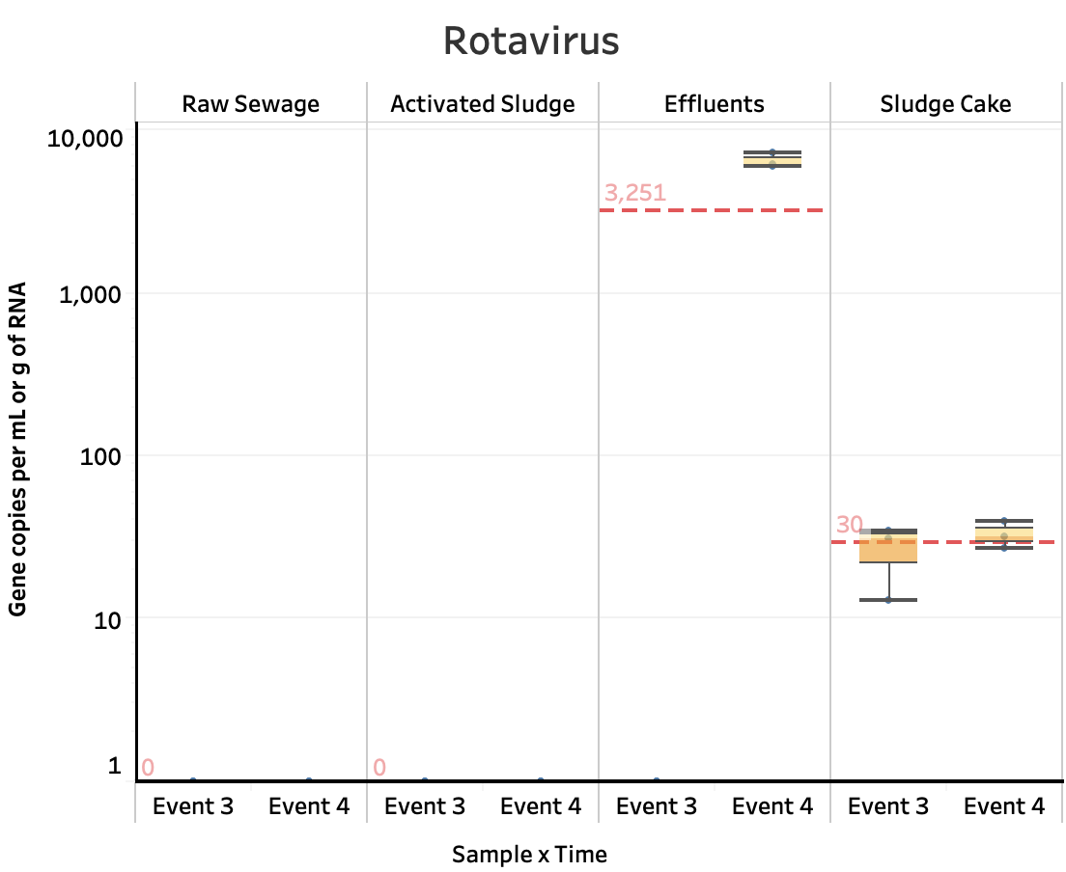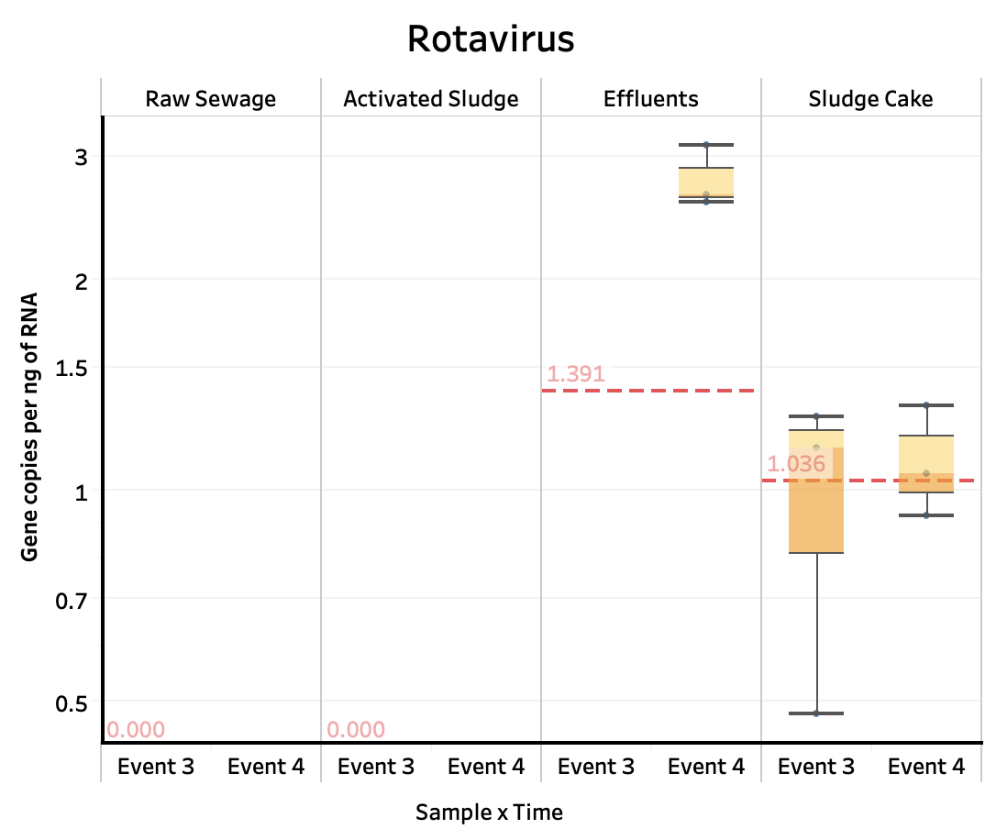

**Figure 6.** Box plot graphs of the number of genes copies of Rotavirus across Events 3 and 4. The units for the sludge cake in Figure 6A are gene copies per gram of RNA.

**6A.**

**6B.**

There were no gene copies of Rotavirus detected (or they were below the detection limit) in raw sewage, activated sludge, effluents, and sludge cake for Events 1 and 2 (fall season). The detection of Rotavirus gene copies for Events 3 and 4 (winter season) were below the detection limit for both the raw sewage and activated sludge. However, gene copies of Rotavirus were detected for the effluents and sludge cake samples for Events 3 and 4 in terms of both volume and biomass.

Furthermore, there was no detection of gene copies for Astrovirus for all the wastewater samples across all Events 1-4. In regards to Sapovirus, the gene copies for Sav1, Sav124, and Sav5 were all below the detection limit for all the wastewater samples across all Events 1-4.

To discard the possibility of inhibitors or contaminants such as humic acids, additional qPCR tests using bovine serum albumin (data not shown) were conducted with environmental samples (including activated sludge). No significant differences were observed in samples with and without the enzyme.

**DISCUSSION**

The gene copy numbers were expressed in terms of biomass and volume (except for sludge cake; it was expressed in grams of sample). ~~because it allows one to analyze if a selection process is occurring within the wastewater treatment facility~~. The higher abundance and more stable signal over time of GCNs of Adenovirus, CrAssphage, and PMMV are more representative targets for conducting comparisons with *E. coli*. Although a significant reduction of Adenovirus, CrAssphage, PMMV and *uidA* was observed consistently in activated sludge samples, the higher gene copy numbers of viruses and *E. coli* observed in the effluents may be associated with the hydraulic retention time (12 hours) in the facility. For each sampling event, samples were collected within a 2-hour period from raw sewage 🡪 activated sludge 🡪 effluents consecutively. As a result, the community quantified in effluents may not completely reflect the changes occurring in the activated sludge during sample collection. Other variables to consider are the overflow of sewage from rainy events and fluctuations in mixed liquor-suspended solids (Pérez, et al. 2019). Table 2 and Table 3 show water quality parameters of wastewater treatment samples from the NESTP and the temperature and precipitation data near the NESTP.

Moreover, the duration of anaerobic sludge digestion is 25 days. In this context, gene copy numbers of virions and *uidA* in the sludge cake were significantly reduced by anaerobic digestion (the by-product was used as compost and landfill). This may explain why the gene copies of *uidA* were lower in sludge cake compared to all treatments. The average gene copies across all wastewater stages (raw sewage, activated sludge, and effluents) for *uidA* were not significantly different in terms of both volume and biomass. When compared to *uidA*, enteric viruses were found at least one (in terms of biomass) to two (in terms of volume) orders of magnitude higher than the *E. coli* marker. This may indicate that enteric viruses are able to survive the wastewater treatment process and suggest that viral particles are being released into the aquatic environment.

Furthermore, the gene copies of CrAssphage and PMMV detected were high in terms of biomass in the sludge cake. Since sludge cake is the by-product of activated sludge and raw sewage using anaerobic digestion, this may mean that the presence of CrAssphage and PMMV may have been lower in the wastewater being treated in the activated sludge, but higher in the solids. However, GCNs of Adenovirus in terms of biomass were not significantly different between the activated sludge and sludge cake samples. This reduction of viral gene copies of Adenovirus may be due to efficient digestion in the activated sludge and the anaerobic digestion process (sludge cake). Meanwhile, plant viruses such as PMMV remain more stable (in terms of biomass) during these digestion processes (Jumat et al. 2017).

The higher presence of Rotavirus gene copies in the effluents during the winter season may indicate a higher risk of transmission during cold seasons (Atabakhsh et al. 2020), since it has been previously reported that a greater presence of rotaviruses in effluents are found during the winter season (Li et al. 2011).

The negative results of Sapovirus (Sav1, Sav124, and Sav5) across all wastewater treatment stages during the fall and winter season are consistent with a report by Varela et al. (2018) using samples from a wastewater treatment plant in Tunisia. Their results did not support the general belief that the peak of detection of Sapovirus occurs during the cold and rainy months of the year. However, quantitative detection of sapovirus in wastewater and river water in Japan showed an increased concentration of sapoviruses in influents between winter and spring (December to May), but a decrease in sapovirus concentration during the summer and autumn months (July to October) (Haramoto et al. 2008). As a result, the concentration of sapoviruses in wastewater can vary across the world due to seasonal variability.

The gene copies of GI Norovirus and GII Norovirus were below the detection limit in the activated sludge samples (in terms of both volume and biomass), but still relatively abundant in the effluents. This may be related to the hydraulic retention time in the NESTP facility or the efficiency in removing these viruses during the process. The relative abundance of GI Norovirus and GII Norovirus gene copies in raw sewage and effluents during the winter months (December and February) and the presence of GII Norovirus in raw sewage in only October may be due seasonal variability (Pérez, et al. 2019). However, the presence of GI and GII Norovirus gene copies in raw sewage in Event 4 (February) is consistent with a study conducted by Flannery et al. (2012), in which the concentration of GI and GII Norovirus gene copies in the influents of a wastewater treatment plant were significantly higher during the winter months (January to March).

In a study conducted by Morsy El-Senousy et al. (2007), high numbers of Astrovirus gene copies (per liter) in sewage water samples (from the Greater Cairo area in Egypt) were observed at the end of autumn and during the winter months, but the Astrovirus concentrations tended to decrease as temperatures increased. These results are significantly different from the quantitation of Astrovirus gene copies in the wastewater samples from the NESTP. There was zero detection of Astrovirus gene copies in all of the wastewater treatment stages across all events. These results may be due to seasonal variability (Pérez, et al. 2019) and efficiency of the wastewater facility in removing this virus during the process.

**~~Limitations~~**

~~Some limitations of this study are the small sample size of each wastewater treatment sample, which may have led to power constraints, and the lack of replication in larger sample sizes. Another weakness of this study is the lack of data for the spring and summer months of the year.~~

**Conclusion:** CrAssphage (a DNA enteric virus) and the Pepper Mild Mottle Virus (PMMV) have been found to be a dominant presence in wastewater samples.

**ACKNOWLEDGEMENTS**

Special thanks to Dr. Qiuyan Yuan and graduate students Palwinder Singh and Kadir Yanaç in Civil Engineering at the University of Manitoba. Research start-up funds grant number 322388 were assigned to Dr. Miguel Uyaguari-Diaz.

**REFERENCES**

1. Atabakhsh, P., Kargar, M., and Doosti, A. 2020. Molecular detection and genotyping of group A rotavirus in two wastewater treatment plants, Iran. *Brazilian Journal of Microbiology*. 51(1):197–203. doi: 10.1007/s42770-019-00131-0.
2. City of Winnipeg. 2019a. Sewage treatment plants: Introduction [online]. Available from https://www.winnipeg.ca/waterandwaste/sewage/treatmentPlant/default.stm#tab-introduction [accessed 6 April 2020].
3. City of Winnipeg. 2019b. Sewage treatment plants: North End Sewage Treatment Plant (NEWPCC) [online]. Available from https://www.winnipeg.ca/waterandwaste/sewage/treatmentPlant/default.stm#tab-north-end-sewage-treatment-plant [accessed 6 April 2020].
4. Dutilh, B.E., Cassman, N., McNair, K., Sanchez, S.E., Silva, G.G., Boling, L., Barr, J.J., Speth, D.R., Seguritan, V., Aziz, R.K., et al. 2014. A highly abundant bacteriophage discovered in the unknown sequences of human faecal metagenomes. *Nat. Commun.* 5(4498): 1−11. doi: 10.1038/ncomms5498.
5. Flannery, J., Keaveney, S., Rajko-Nenow, P., O’Flaherty, V., and Dore, W. 2012. Concentration of norovirus during wastewater treatment and its impact on oyster contamination. doi: 10.1128/aem.07569-11.
6. Government of Canada. 2019. Historical Data [online]. Available from <https://climate.weather.gc.ca/historical_data/search_historic_data_e.html> [accessed 6 April 2020].
7. Haramoto, E., Katayama, H., Phanuwan, C., and Ohgaki, S. 2008. Quantitative detection of sapoviruses in wastewater and river water in Japan. Letters in Applied Microbiology, 46(3): 408-413. doi: 10.1111/j.1472-765X.2008.02330.x.
8. Jumat, M.R., Hasan, N.A., Subramanian, P., Heberling, C., Colwell, R.R., and Hong, P. 2017. Membrane Biorector-Based Wastewater Treatment Plant in Saudi Arabia: Reduction of Viral Diversity, Load, and Infectious Capacity. *Water* 9(7): 534. doi:10.3390/w9070534.
9. Li, D., Gu, A., Zeng, S.Y., Yang, W., He, M., and Shi, H.C. (2011) Monitoring and evaluation of infectious rotaviruses in various wastewater effluents and receiving waters revealed correlation and seasonal pattern of occurrences. J Appl Microbiol 110(5): 1129–1137. doi: [10.1111/j.1365-2672.2011.04954.x](https://doi.org/10.1111/j.1365-2672.2011.04954.x).
10. Morsy El-Senousy, W., Guix, S., Abid, I., Pinto, R., and Bosch, A. 2007. Removal of Astrovirus from Water and Sewage Treatment Plants, Evaluated by a Competitive Reverse Transcription-PCR. *Applied and Environmental Microbiology*, 73(1): 164–167. doi: 10.1128/AEM.01748-06.
11. Pérez, M.V., Guerrero, L.D., Orellana, E., Figuerola, E.L., and Erijman, L. 2019. Time Series Genome-Centric Analysis Unveils Bacterial Response to Operational Disturbance in Activated Sludge. *MSystems*, 4(4): e00169-19. doi: 10.1128/mSystems.00169-19.
12. Ritalahti, K.M., Amos, B.K., Sung, Y., Wu, Q., Koenigsberg, S.S., and Löffler, F.E. 2006. Quantitative PCR Targeting 16S rRNA and Reductive Dehalogenase Genes Simultaneously Monitors Multiple *Dehalococcoides* Strains. *Applied and Environmental Microbiology,* 72(4): 2768. doi: 10.1128/AEM.72.4.2765-2774.2006.
13. Stachler, E., Kelty, C., Sivaganesan, M., Li, X., Bibby, K., and Shanks, O.C. 2017. Quantitative CrAssphage PCR assays for human fecal pollution measurement. *Environ. Sci. Technol*. 51(16): 9146-9154. doi: 10.1021/acs.est.7b02703.
14. Varela, M., Ouardani, I., Kato, T., Kadoya, S., Aouni, M., Sano, D., and Romalde, J.L. 2018. Sapovirus in Wastewater Treatment Plants in Tunisia: Prevalence, Removal, and Genetic Characterization. *Applied and Environmental Microbiology*. 84(6): e02093–17–17.atom. doi: 10.1128/AEM.02093-17.
15. Zhang, T., Breitbart, M., Lee, W., Run, J., Wei, C., Soh, S., et al. (2006). RNA Viral Community in Human Feces: Prevalence of Plant Pathogenic Viruses. *PLoS Biology*. 4(1): e3. doi: 10.1371/journal.pbio.0040003.